Supplementary File 1

- BONSAI workflow and EMG acquisition

Electromyography (EMG) was acquired using a custom-built system at a sampling rate of 4,000 Hz, with analog filtering applied above 1 Hz and below 2,000 Hz. The system includes five independent EMG channels and an additional channel receiving direct input from the TMS device, enabling precise temporal alignment of pulse delivery. Acquisition parameters followed established international guidelines for TMS–EMG studies (Groppa, ensuring methodological rigor and data reliability. While the Bonsai workflow allows users to modify the sampling frequency, we recommend at least 4,000 Hz, based on both our experience and published guidelines. Data is streamed via Bluetooth and processed in real time using a dedicated Bonsai workflow, which supports efficient integration and synchronization of signals. All recordings are stored in binary (.bin) format, allowing high-resolution offline analysis. This setup enhances the robustness of signal acquisition and supports the reproducibility of the protocol.

The acquisition system was validated against a commercial EMG device (see Supplementary Material in Faro Viana et al. for details). Systems can be requested from the hardware platform at Fundação Champalimaud. The Bonsai workflow is openly available at https://github.com/OliveiraMaiaLab/tms-emg-acquisition.git.

Below, we provide a step-by-step guide to setting up EMG acquisition with the Bonsai workflow:

  - Open the Bonsai software and choose the file where the script for EMG data acquisition was developed:
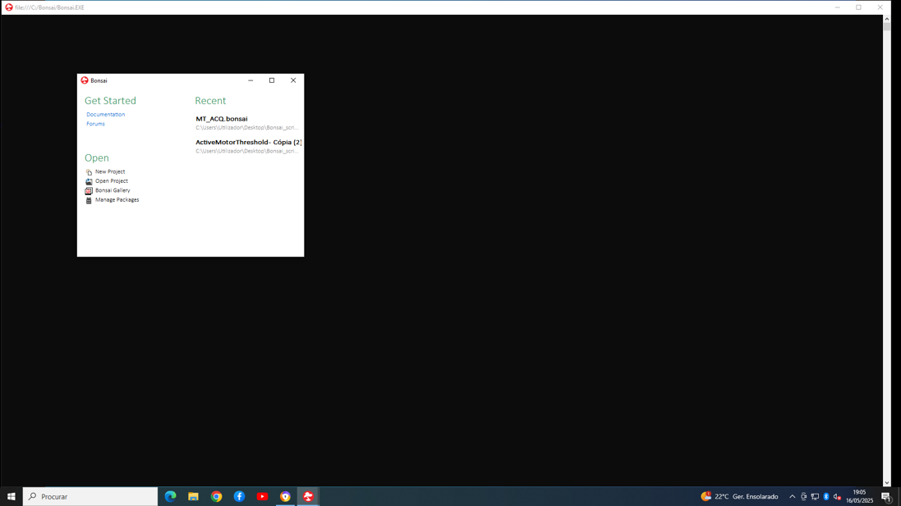

  - Once all the preparations for the sessions are concluded, proceed to start the script

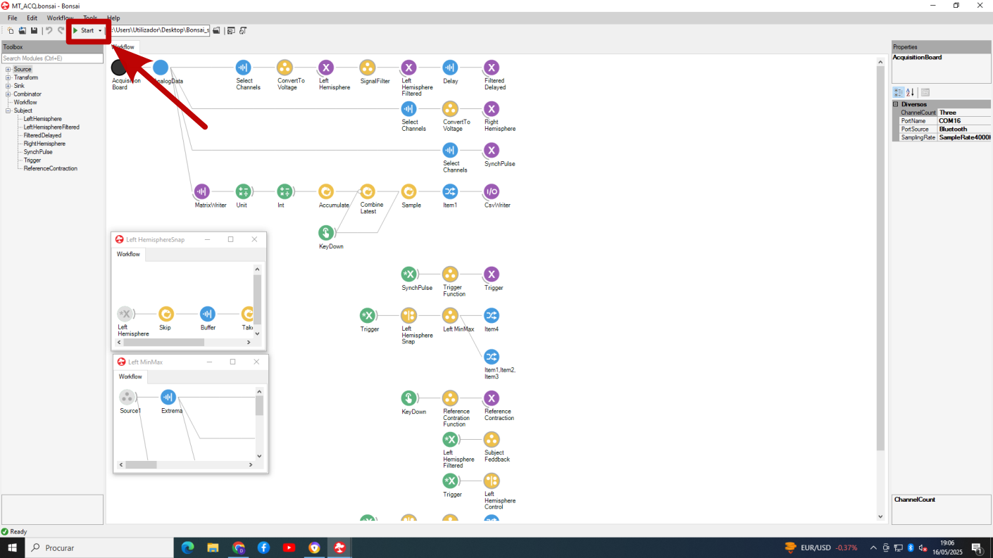

  - After step 3.4, 3 lines will appear on the right-hand side window; Instruct the participant to perform the movement described in step 3.4.1 so that the blue line will be placed in between the yellow and orange ones; Once a pulse is applied, the consequent EMG is valid, if the word “True” appears in the screen (see the red box in the picture below). Otherwise, the results of the pulse shouldn’t be considered.
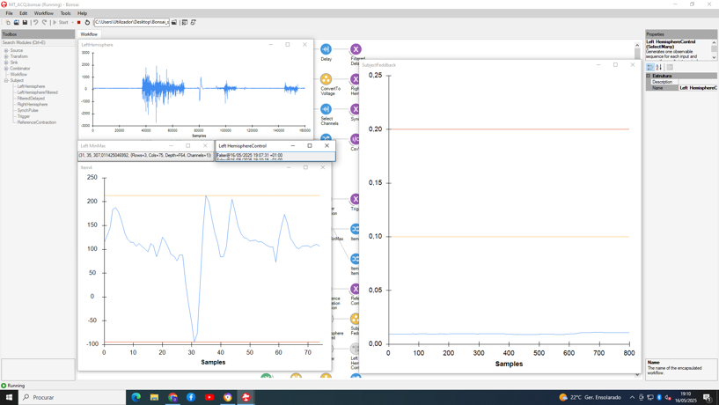
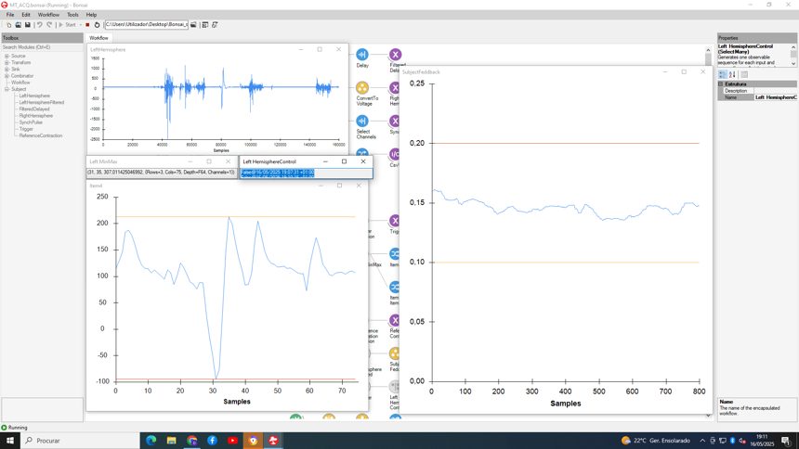

To finish the session, press here.

- TMS machine (MagrPro X100 – MagVenture with a Cool B-65 coil):

  - In the main menu, select the protocol intended to be used – previously defined (red box); Press the recovery button (green box); Press the timing button (yellow box).

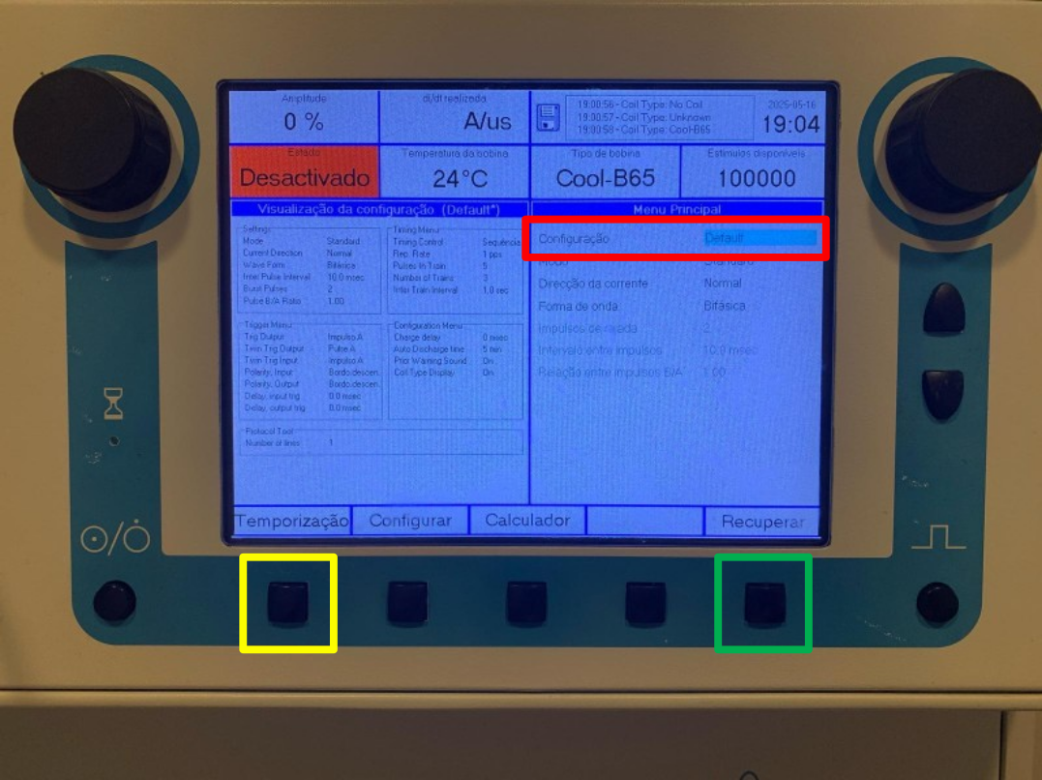

  - For the MEP’s protocol (step 3.6.2): Press the enable button (red box); rotate the left hand side knob (green box) until you have the MSO (%) corresponding to the RMT established in step 3.3; Press the start button (yellow box) to initiate the protocol.
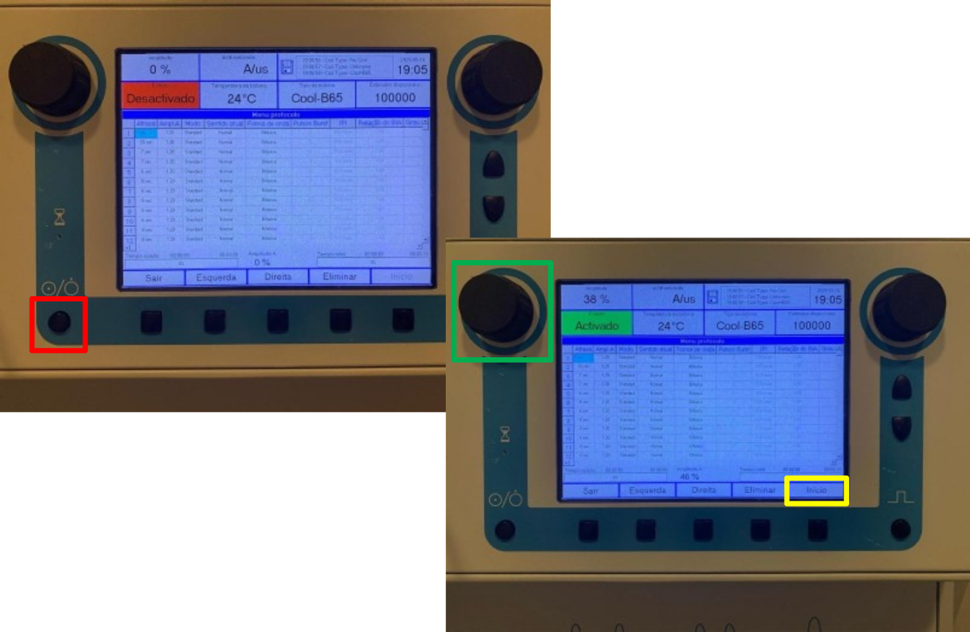

  - For the iTBS administration (step 3.6.3) select the respective protocol as described in step 2.1 (above) and start stimulation as described in step 2.2 (above): Press the enable button (red box); rotate the left hand side knob (green box) until you have the MSO (%) corresponding to the AMT established in step 3.5; Press the start button (yellow box) to initiate the protocol.

- ANT Neuronavigation system (Visor 2):

  - Start by validating the TMS coil: Press settings and then choose TMS coils.
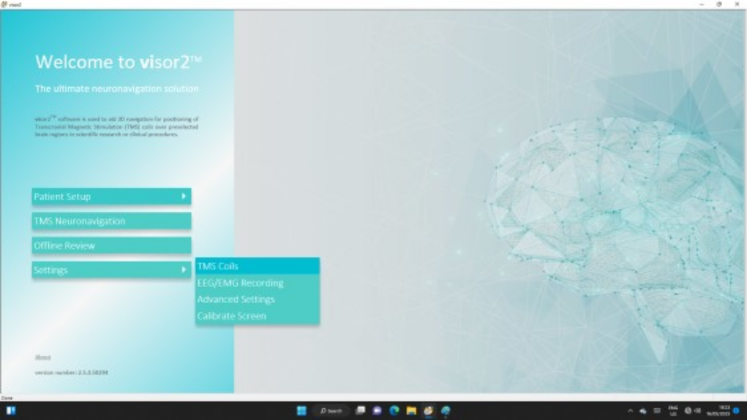

  - Go to the Modify Existing Coil tab and select corresponding to the one intended to be used in the protocol; Press Calibrate Tool Faces.
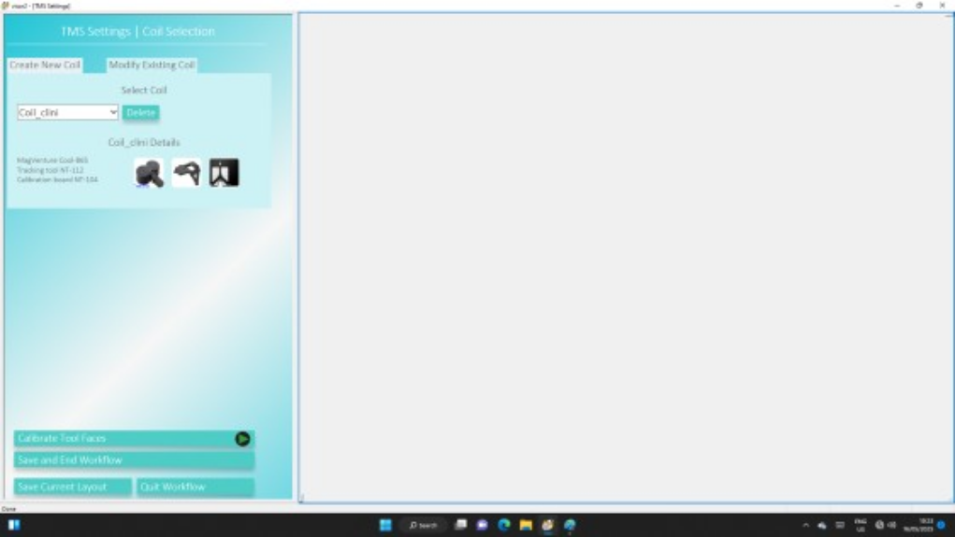

  - Face the TMS coil to the camera and, once the Coil face 1 and Coil face 1 appear green, press calibrate.

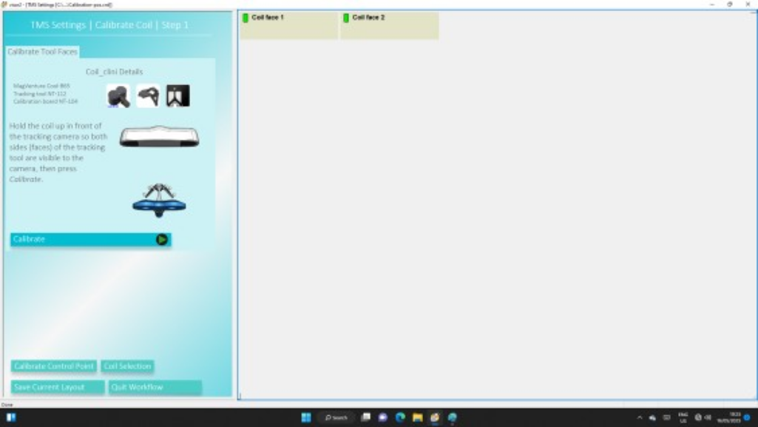

  - Place the pointer in the coil as depicted in the red box below; When both pointer and coil appear green on the monitor, press calibrate; Press Calibrate Coil Center.
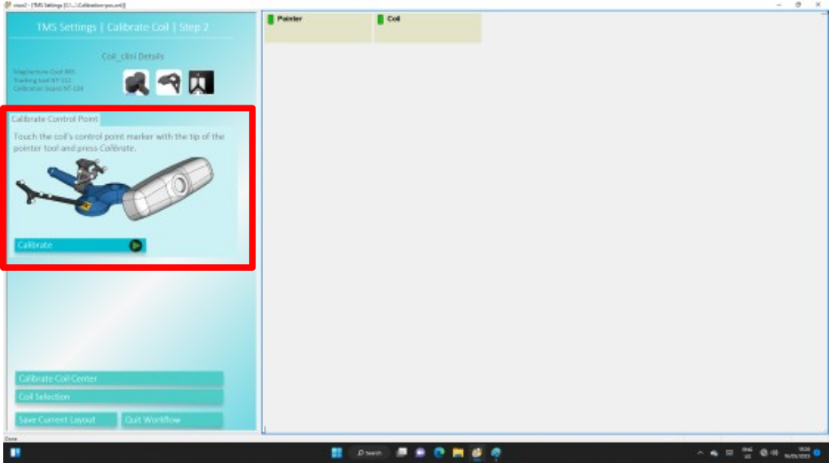

  - Point the calibration board and the coil towards the camera. When both the calibration board and the coil appear green, press calibrate; Press neuronavigation.
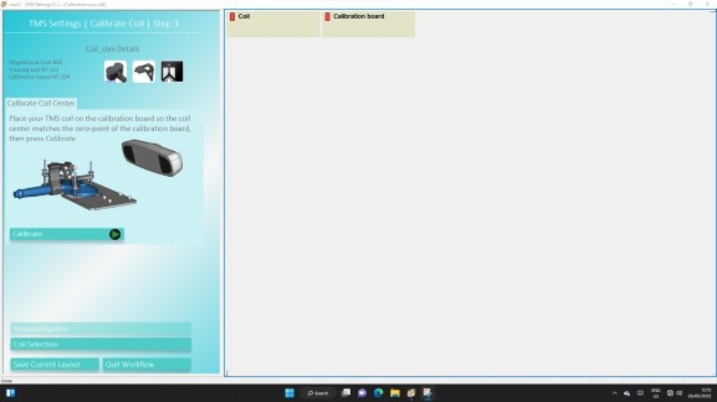

  - Validate the coil calibration by selecting the respective TMS coil (See red box).
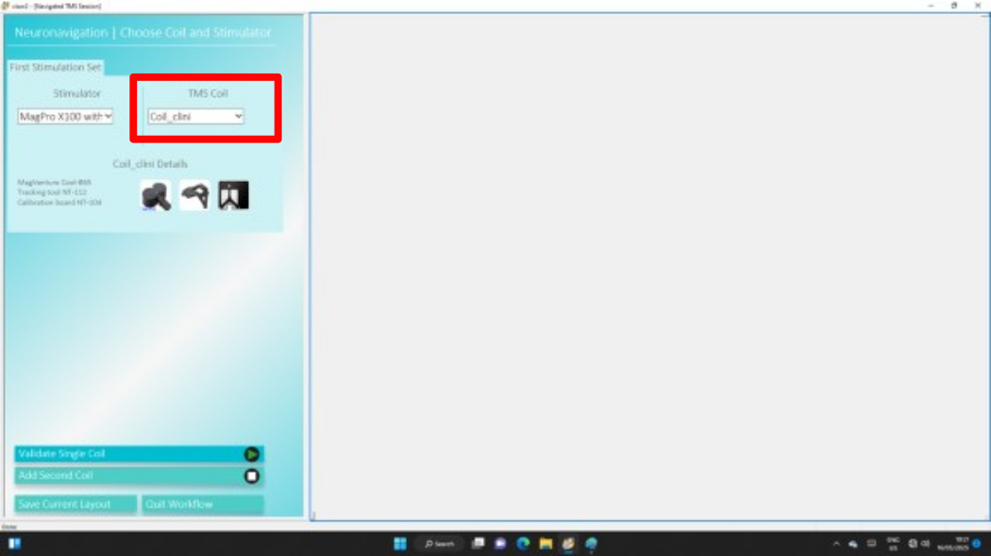

  - Place the pointer in the coil as depicted in the red box below; When both pointer and coil appear green on the monitor, press Validate; Press Select patient.
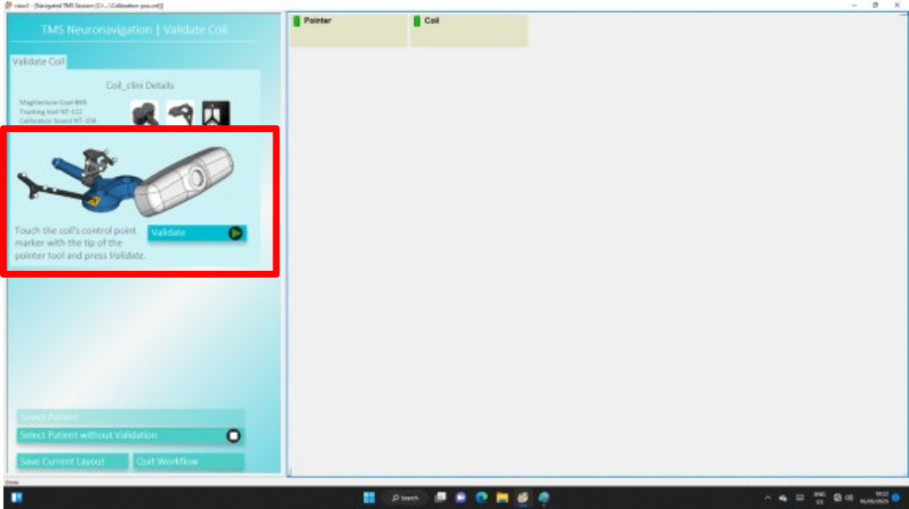

  - Create the participant ID; Use standard MRI or insert the personalized MRI for each participant. From here on, we describe the methods for standard MNI, as used in Seybert et at (2023); Press Define Targets

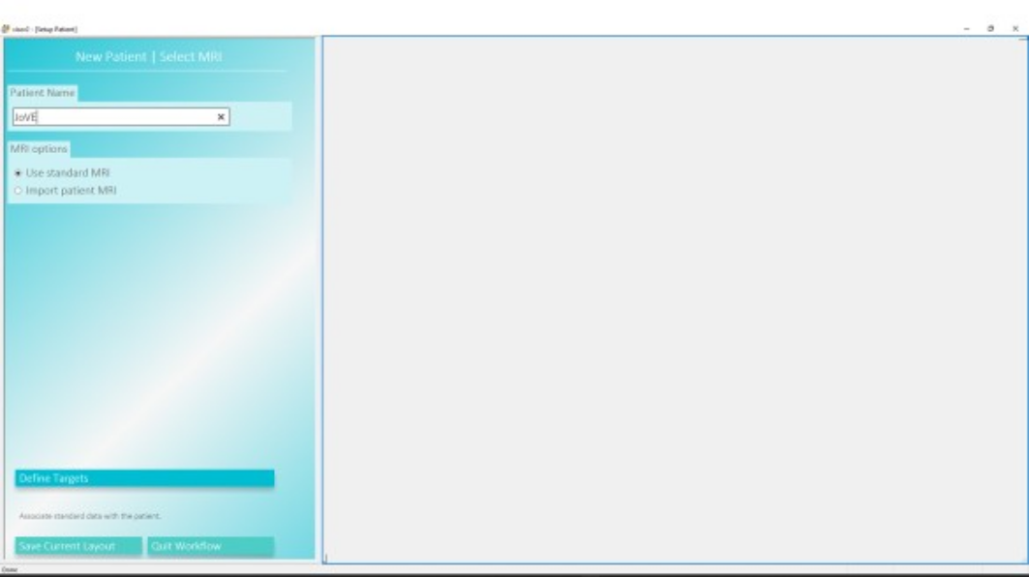

  - Press Define Coordinate System.
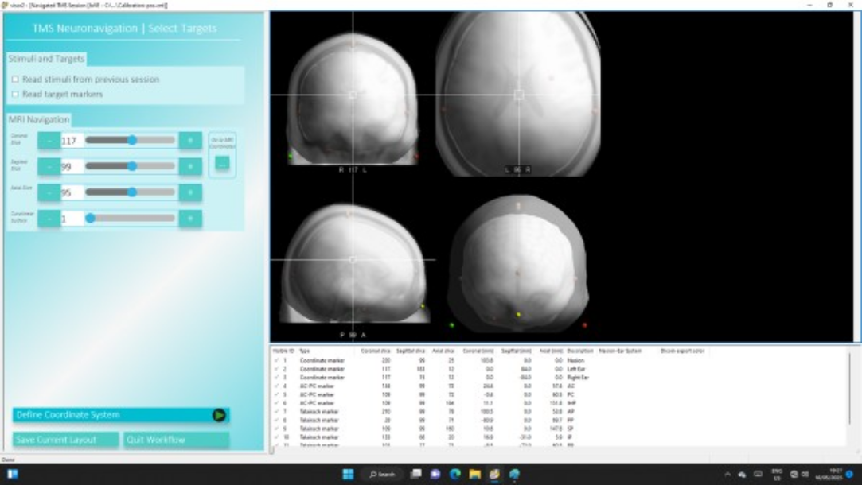

  - Place the pointer on the designated coordinates. First, place it in the nasion and press Acquire. Second, place it in the left ear and press Acquire. Then, place it in the right ear and press Acquire. Finally, press Head Shape Points.
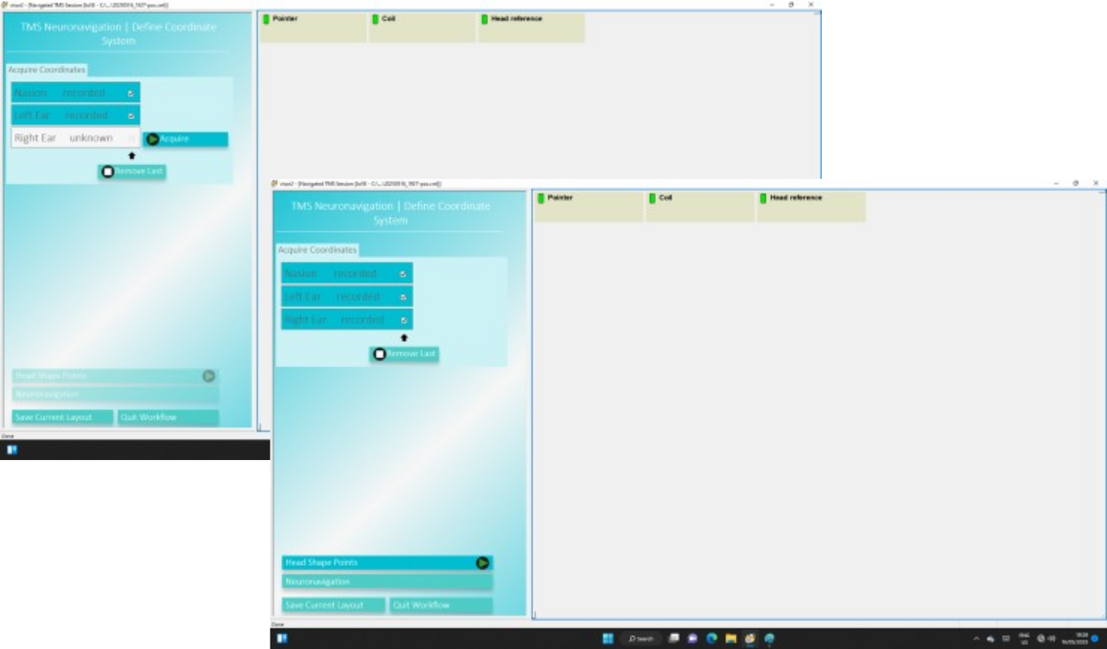

  - Press Start and circle the pointer around the participant’s scalp; Once around 300 points are generated, hit Pause. Press Neuronavigation.
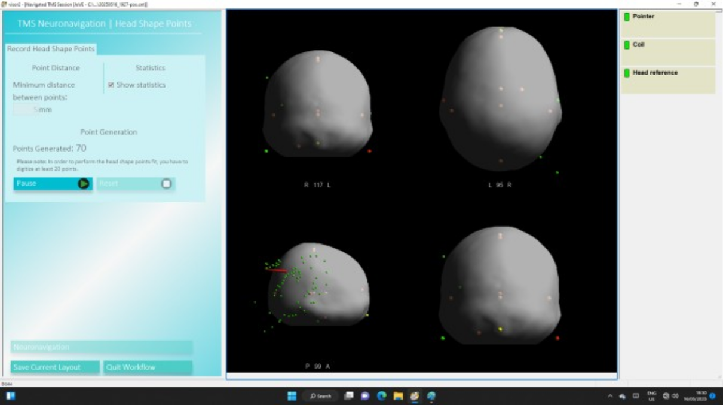

  - Start assessing the Motor Hotspot; ONCE defined, select the pulse number corresponding to the motor hostspot (Green Box). Press Reproduce Stimuli (Red Box); Proceed with the following protocol points.
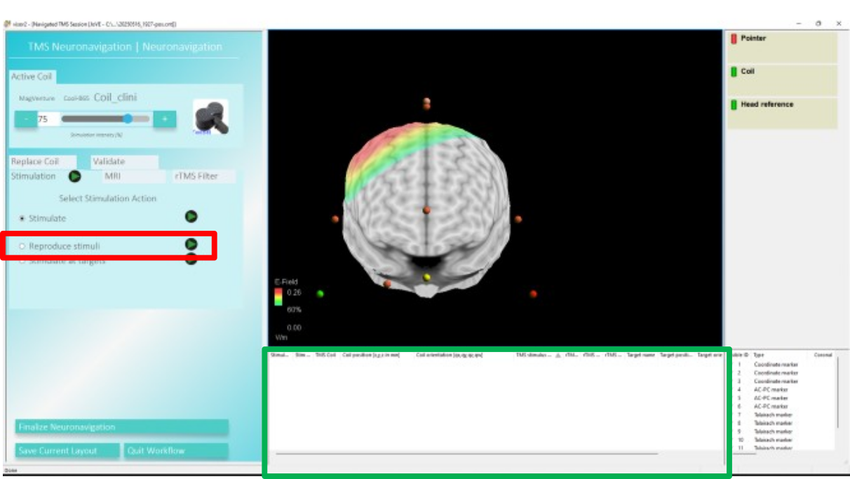

- MEP preprocessing:

Offline analysis of MEPs was performed using a structured preprocessing pipeline. Raw EMG signals were denoised with a three-level adaptive wavelet filter (Daubechies family, db1) and BayesShrink soft thresholding (Chang et al., 2000). Wavelet filtering is particularly effective for non-stationary signals and for separating noise sources with overlapping frequency content (Samann & Schanze, 2019; Wahab & O’Haver, 2020; Machetanz et al., 2021). A third-order Savitzky–Golay filter with a window size of 5 (Awal et al., 2011) was then applied for smoothing. This approach was preferred over conventional band-pass filtering, which introduced distortions in our dataset.

Following preprocessing, MEPs were screened according to established exclusion criteria. Trials were discarded if they showed pre-activation or if peak-to-peak amplitude was <50 μV. Background EMG was assessed with an automated procedure: a 500 ms artifact-free segment of EMG was selected as baseline, and the 50 ms preceding each TMS pulse were compared against it. Pre-activation was defined when the rectified mean amplitude exceeded baseline by >2 SD (McCambridge et al., 2020) or if the root mean square amplitude exceeded 15 μV (Hinder et al., 2014). Trials meeting both conditions were excluded.

The pipeline is designed for MEP analysis and amplitude extraction, requires minimal coding expertise, and is available at https://github.com/OliveiraMaiaLab/tms-emg-preprocessing.git, alongside a step-by-step guide.

